**NCFE Functional Skills Qualification in Information and Communication Technology (ICT) at Entry Level 2 (600/1353/9)**

**Learner Tasks**

**Set A (Sample) – The Nature Trail**

|  |
| --- |
| Learner name: |
| NCFE Learner number: |
| Centre name: |
| Date assessment started: |
| Date assessment finished: |

|  |
| --- |
| *I confirm that this assessment is my own work.*  Learner signature: Date: |

**Instructions for Learners**

Time Allowed: 2 hours maximum

Make sure you are comfortable before you start.

Read the questions carefully. If you do not understand what you have to do, ask your Assessor.

Follow the instructions for each question. Check your work.

When looking for and openingdocuments, your Assessor will tell you where they are stored.

You will need to save and print your work. **You can ask for help with this.**

There are **54 marks** available for this assessment.

At the end of the assessment please give all documents to your Assessor.

**This page is intentionally left blank**.

**Introduction**

Your Assessor will also read this out to you.

|  |
| --- |
| We should all try to work safely. We all need to think about health and safety.  You will complete a health and safety check for your computer work area.  You will also answer some questions about ICT health and safety.  You will show that you can work with emails.  Your help is needed to design an information leaflet. It is for a trip to a nature centre.  You will also need to correct a checklist for the trip.  You will print off your work. |

**You must show that you can work safely during this assessment.**

**Task 1 (4 marks)**

1. Check that your computer work area is safe. (1 mark)
2. Your Assessor will ask you **four** questions about computer health  
   and safety. (3 marks)

**Task 2 (10 marks)**

1. Use a password to log in to the computer. (4 marks)
2. Log in to your emails. (4 marks)
3. Find, open and read the email with the subject: **Day Out** (2 marks)

**Task 3 (5 marks)**

1. Write a reply to the sender of the email. (2 marks)
2. Which two pictures below would be best for the leaflet?   
   Put this information in your email to the sender. (1 mark)

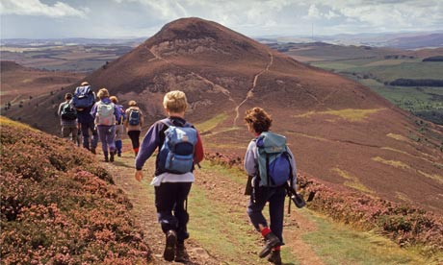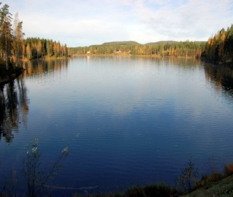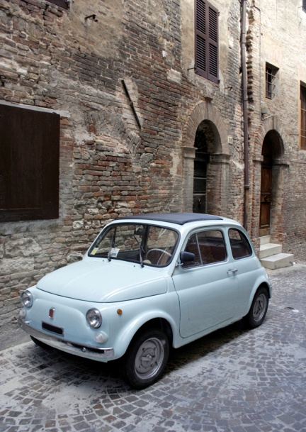

**2**

**1**

**4**

**3**

1. Send your reply. (2 marks)

**Task 4 (12 marks)**

**Make the information leaflet**

1. Find the file: **Nature Centre Trip**  (2 marks)  
   **Your Assessor will tell you where to search for the fil**e.
2. Use your computer to find a **new** image for the leaflet. (2 marks)

Below are some ideas for images:

* wildlife
* country scenes
* woodland.

1. Insert the image on to the leaflet. (2 marks)
2. Insert the text below on to the leaflet. (2 marks)

*What you will see at the Nature Centre*

*Birds*

*Wildlife*

*Insects*

*What you will do at the Nature Centre*

*Walk in the woods*

*See lots of birds*

*Look for wild life*

*And lots more!*

1. Use bold formatting to show important parts of the text. (4 marks)  
   Use different sizes of font to show important parts of the text.  
   **Make sure you save your leaflet.   
   You can ask for help to do this.**

**Task 5 (14 marks)**

1. The details below need to go at the bottom of the leaflet. (4 marks)

**Please email Jade or Simon if you want to go: jade&simon@hello.biz**

1. Change the font style **and** font size of the details. (2 marks)
2. Make the leaflet look good. (2 marks)  
   You should use at least **two** of the following:

* fonts
* font styles
* alignment
* borders
* colour.

1. Make sure that everything is easy to see and read. (4 marks)

Check:

* fonts
* image
* layout.

1. Put your name on your work. (2 marks)

Print the leaflet.   
**Make sure you save your leaflet.   
You can ask for help to do this.**

**Task 6 (9 marks)**

1. Find the document: **Trip Checklist** (2 marks)

**Your Assessor will tell you where to search for the document.**

1. Correct the title. It should be: **Trip Checklist**  (2 marks)
2. There are **two** spelling errors. Correct these errors. (3 marks)

* Change **Sentre** to Centre.
* Change **eemail** to email.

1. Put your name on your work. (2 marks)

Print the checklist.

**Make sure you save your copy of the Trip Checklist.  
You can ask for help to do this.**

**End of Assessment**